**David Tran**

**CSC 600-02**

**HW #3 PROLOG**

**3/17/2016**

**Dr. Jozo Dujmovic**

**1. Write a PROLOG program that investigates family relationships using lists.**

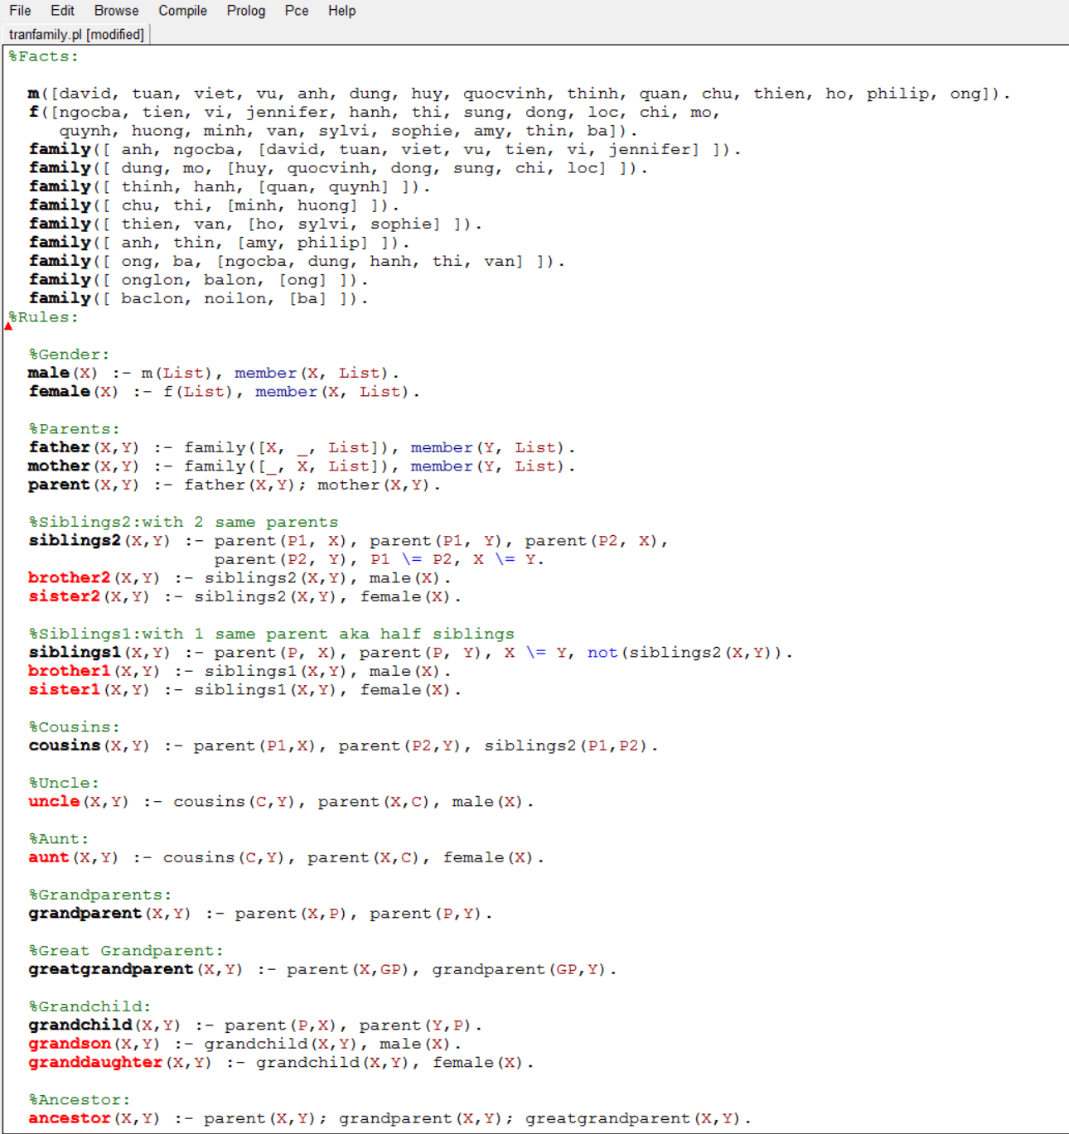

**1. Output:**

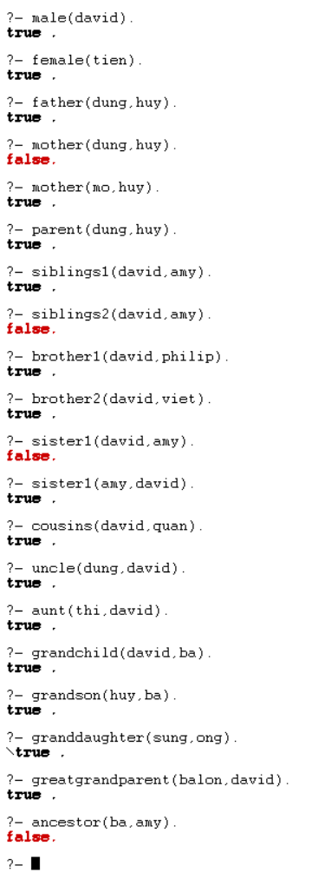

**Write a PROLOG program that includes the following operations with lists:**

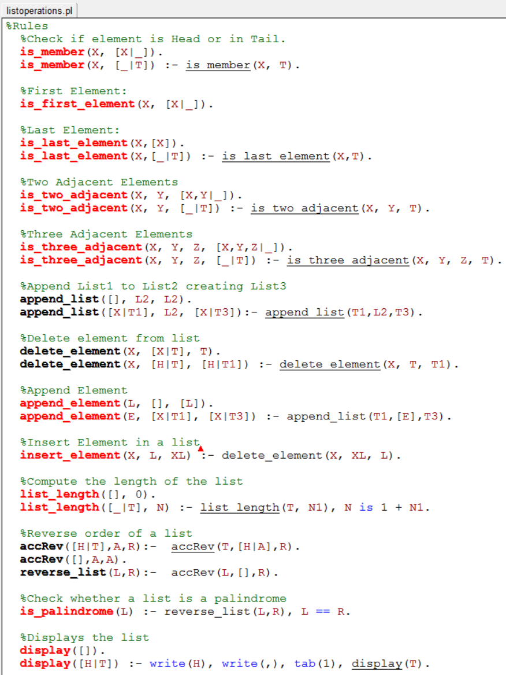

**2. Output:**

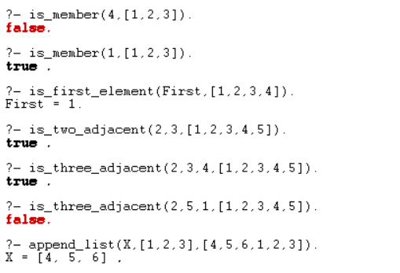

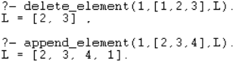**_______________________**

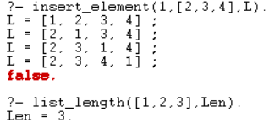**­_______________________**

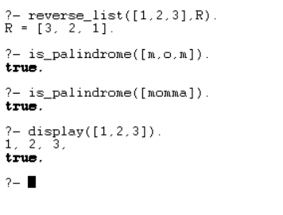

**3. Write a PROLOG program that solves the 8 queens problem.**

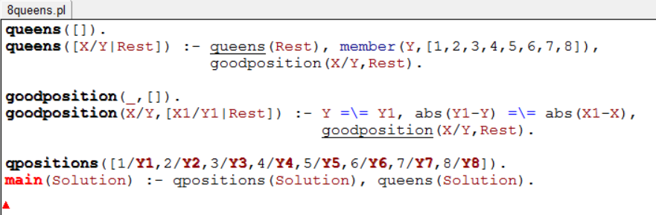

**3. Output:**

